|  |  |  |
| --- | --- | --- |
| **LAB221 Assignment** | **Type:** | **Short Assignment** |
| **Code:** | **J2.S.P0017** |
| **LOC:** | **40** |
| **Slot(s):** | **1** |

**Title**

Working with JTree

**Background Context**

You often see a tree folder in window explorer; in java you can use JTree to show the list of item as hierarchy order.

**Program Specifications**

Create an application using java swing to create a frame look like (1).

**1. Main.java**

Make a frame look like description below.

***Function details:***

1. Display the GUI like figure (1) and (2).
2. When users select an item from the tree, display corresponding data of selected item. We had provided the list of html files, each leaf node in tree associated with a html file. Whenever users select an item (that is a leaf) from the tree, display the content of selected leaf node in corresponding html file.

***Expectation of User interface:***

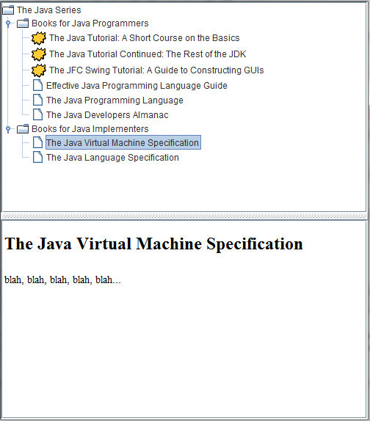

**Guidelines**